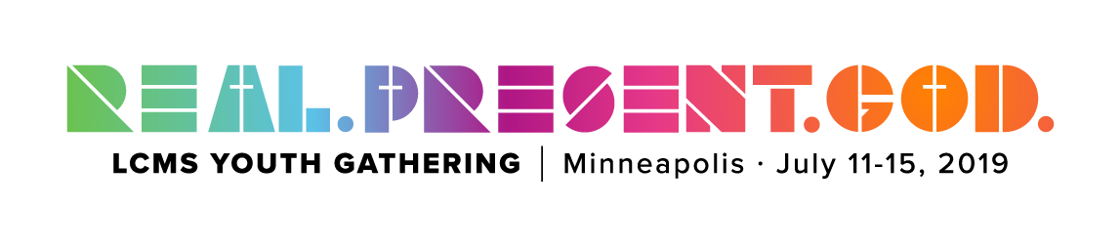2019 Youth Gathering
The Basics
What is the Youth Gathering?

“Held every 3 years since 1980, the LCMS Youth Gathering (Gathering) provides thousands of youth and adults the opportunity to come together as a community of God’s people to learn more about Jesus Christ...During the five days of the Gathering, youth spend time together in God’s word, worship, service and fellowship.” -lcmsgathering.com
Who can go?
Must be at least 14 or going into 9th grade up until summer after senior year at the time of the Gathering. You do not need to be Lutheran to attend! Bring a friend!
Date and Location
July 11-15, 2019 in Minneapolis, Minnesota at the Convention Center and U.S. Bank Stadium
Tentative Timeline and Travel Itinerary
September 30 2018 Fundraiser Car Wash
September 30, 2018 Registration Due
Fall 2018 and Spring 2019 Team Meetings, Bible Studies, and Fundraisers
Late Spring 2019 All Funds Due If Needed
July 10, 2019 Leave for Minneapolis
July 11-15, 2019 Attend Gathering Activities
July 15-16, 2019 Youth-Elected Fun Event in Minnesota
July 16/17, 2019 Return to Missouri

Cost (initial estimate)
$ 90 Transportation
$ 400 Hotel
$ 365 Registration
$ 240 Food
$ 150 District and Group Activities
$ 1245 Total Cost

For more information
Talk to Paul!
youth@kokstl.org
Church: 314-469-2224
Cell: 402-910-6530
Visit the website!
lcmsgathering.com

Fundraising Plan (September 2018-July 2019)

Fall Car Wash (2018)-September 30th
Cardinals Calendar Fundraiser (2018)-Late Oct.-Early Nov.
MOPS Trivia Night (2019)-Feb./Mar.
Papa Murphy’s Fundraiser Feb./Mar.
Ash Wednesday Meal (2019)-Mar. 6th
Spring Car Wash (2019)-April/May
Easter Breakfast (2019)-April 21st
Bible Study Plan (September 2018-July 2019)*
November
February
April
July
*Dates will be added after discussion with group about what days work best
How to Register
- Fill out sign-up sheet (hand that in ASAP!)
- After I receive the sign-up sheet, I will be able to get you a registration form after September 5th. (This needs to be filled out and returned by September 30th.)
- Look over covenant (understanding the requirements for going ie. Attending all Bible studies and fundraisers, having a parent attend if youth is unable, and communicating if not at all able to attend certain events) and have parents and youth sign it.
- (Turn in by September 30th.)
- Turn in a deposit of $200 to the church office.
Possible Fun Choices
- Valley Fair Amusement Park
- Twins Baseball Game
- Afton State Park (Kayak and Hiking)
- Minnehaha Falls (cool waterfalls and hiking)
- Mall of America (it’s a mall…with an amusement park)
- Camp Okoboji (play on the lake all day and stay the night)

